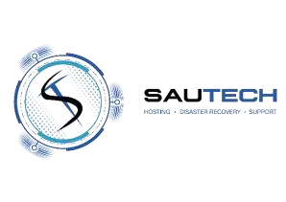

RSA

Namibia

34
Stokroos Ave

Regus

Breaunanda

Maerua Mall, 3
rd

Floor

1739

Phone:

011

768 1790

Phone:

+264 (0)

61

435 8232

Email:

sales@sautech.net

Email:

sales@sautech.com.na

Reg No:

2003/006814/07

Reg No:

2023/0508

Vat No:

4240211963

Vat No:

13757380
-
015

ACCOUNT APPLICATION FORM
:

Company
/ Individual Details

Full Company
/ Individual
Name; James Bruce HARRISON_

Physical Address: __7 ARIZONA CRESCENT, NORTHCLIFF Ext 15, Johannesburg 2195

Office Number: _+27833250025
______
__

Registration Number: ________________________________________________________________
________

Vat Number: _______________________________________________________________________
________

Representative Name: Bruce Harrison
____________________
________

Representative Email; bruce@jbharrison.co.za
________

Account Authorised Personnel

Full Name and Surname: _AS ABOVE
________

Mobile

Number: +27833250025
________

Office Number: +27833250025
________

Email Address:
_bruce@jbharrison.co.za____________________________________________________________________
________

Primary (
Technical
Contact Person
)

Full Name and Surname: __Bruce Harrison
________

Mobile Number: +27833250025
_
________

Office Number: : +27833250025
________
_

Email Address: bruce@jbharrison.co.za
________

Signed at _Jiohannesburg
__

on this 4th
__

day of June_______________
__
2025

J B HARRISON

_Owner

Print Name

Designation

SIGNED ELECTRONICALLY _____________________________
Signature Witness

Sautech Account Application Form www.sautech.net

